



|  |
| --- |
| **TAIEX Study Visit on Creation of the national coordination network in the field of transplantation** |
| ***Organised in co-operation with***  *The Transplant Agency of Moldova and Slovenija Transplant* |
| ***14 - 18 April 2025***  ***Venue:***  *Slovenija-transplant*  *Zaloška cesta 7*  *1000 Ljubljana*  *Slovenia*  ***Beneficiary:***  *Moldova*  TAIEX Case ID AGR IND/STUD 90386 |



­

|  |
| --- |
| **Aim of the Study Visit:** |
| The primary aim of the **Study Visit on the Creation of the National Coordination Network in the Field of Transplantation** is to support the development and implementation of an effective, centralized system for managing organ, tissue and cell donation and transplantation processes. The visit focuses on sharing best practices, enhancing understanding of European models, and providing guidance on establishing a robust coordination network tailored to the specific needs of Moldova. This initiative is expected to lay the groundwork for a sustainable and ethical transplant coordination system in Moldova, significantly improving access to life-saving treatments. |

|  |
| --- |
| **Participants / Speakers:** |
| * **Ms Diana Buga**   Main consultant, Directorate for policy in the field of hospital medical assistance  Ministry of Health, Moldova   * **Ms Ludmila Ciubotaru** Head of Service for the coordination and Monitoring of MAR   Transplant Agency of Moldova   * **Ms Liliana Iamandii** Lawyer   Transplant agency of Moldova   * **Ms Tatiana Timbalari** Head of Transplantology Department   Transplant Agency of Moldova   * **Mr Dorian Visterniceanu** Head of Informatics Systems and Logistic Department   Transplant Agency of Moldova |
|  |

***Data Protection:*** *Personal data contained in this document is processed in accordance with the privacy statement of the TAIEX instrument in compliance with Regulation (EU) 2018/1725. The chairperson should inform all persons attending the event that photographs/pictures should only be taken during a set period of time to allow for persons who do not agree to have their photographs taken to leave the room, unless all of the participants have provided their express consent to having their photograph taken.*

*See* [*https://ec.europa.eu/neighbourhood-enlargement/sites/near/files/taiex_privacy_statement_online.pdf*](https://ec.europa.eu/neighbourhood-enlargement/sites/near/files/taiex_privacy_statement_online.pdf)

|  |  |
| --- | --- |
| **Day 1: Monday 14 April 2025** | |
| **Chair: Ms Danica Avsec, deputy director, Slovenija-transplant** | |
| Local time  ***8:30 – 9:00*** | *Registration, connecting participants, technical verifications* |
| **9:00 – 09:15** | **Welcome and introduction:**   * Mr Andrej Gadžijev, director, Slovenija-transplant |
| **9:15 – 10:00** | **Overview of the Legal and Institutional Framework for Transplantation in Slovenia**   * Legislation on organ, tissue and cell donation and transplantation * Consent Models: Mixed model   **Speaker**: Mr Andrej Gadžijev, director, Slovenija-transplant, Slovenia |
| **10:00 – 10:45** | **Overview of the Legal and Institutional Framework for Transplantation in the Republic of Moldova**   * Key elements of the national transplant system and its legislative underpinnings * Consent Model: Mixt Consent   **Speaker:** Ms Tatiana Timbalari, chief, Transplantology department, Transplant Agency, Republic of Moldova |
| ***10:45 – 11:00*** | *Break* |
| ***11:00 – 11:30*** | **Visit** |
| **11:30 – 12:30** | **EU normative acts regarding the creation of the national coordination network in the field of transplantation**   * Directive 2010/53/EU of the European Parliament on standards of quality and safety of human organs intended for transplantation * Commission Implementing Directive 2012/25/EU of 9 October 2012 laying down information procedures for the exchange, between Member States, of human organs intended for transplantation   **Speaker** Ms Danica Avsec, Slovenia |
| ***12:30 – 14:00*** | *Lunch break*  *Please be reminded to sign the attendance list* |
| **14:00 – 14:45** | **Organizational and structural aspects**   * Structure of national coordination network * Role of Central and Regional/hospital transplant coordinators   **Speaker:** Mr Andrej Gadžijev, Slovenia |
| ***14:45 – 15:00*** | *Break* |
| **15:00 – 15:45** | **Organizational and structural aspects**   * Integration of transplant centre into the national coordination network * Cooperation of Donor Centres, Transplant Centre and Slovenija-transplant   **Speaker:** Mr Ivan Kneževič, Slovenia |
| **15:45– 16:00** | AOB and wrap up of day 1 |

|  |  |
| --- | --- |
| **Day 2: Tuesday 15 April 2025** | |
| **Chair: Mr Andrej Gadžijev, director, Slovenija-transplant** | |
| ***Local time 8:30 – 9:00*** | *Registration of participants, connection of participants, technical verifications* |
| **9:00 – 09:45** | **Operational and technical topics**   * Donor identification and management in the Republic of Moldova * Organ procurement and national allocation protocols   **Speaker**: Mr / Ms First name Family name, Republic of Moldova |
| **09:45 – 10:30** | **Operational and technical topics**   * Donor identification and management. Slovenian model * Organ procurement and allocation protocols   **Speaker:** Ms Ana Marija Štrucl, Slovenia |
| ***10:30 – 10:45*** | *Break* |
| **10:45 – 11:45** | **Operational and technical topics**   * Protocols for transplant coordination in Donor Centres and Transplant Centre * Maintaining a national donor registry   **Speaker:** Ms Ana Marija Štrucl & Mr Gorazd Čebulc, Slovenia |
| ***11:45 – 13:00*** | *Lunch break*  *Please be reminded to sign the attendance list* |
| **13:00 – 13:45** | **Organ Donation models**   * Strategies to increase donor detection * Financing models for transplant coordination network   **Speaker:** Mr Andrej Gadžijev, Slovenia |
| ***13:45 – 14:00*** | *Break* |
| **14:00 – 14:45** | **Funding and sustainability**   * Financial aspects: financing of the Slovenia-transplant institute as a public institution * Financial aspects: financing of transplant coordination network (on-call teams 24/7: central transplant coordinator, hospital coordinator, brain death determination team, organ procurement team)   **Speaker:** Mr Boštjan Kušar |
| **14:45 – 15:00** | AOB and wrap up of day 2 |

|  |  |
| --- | --- |
| **Day 3: Wednesday 16 April 2025** | |
| **Chair: Mr Andrej Gadžijev and Ms Danica Avsec** | |
| Local time  ***8:30 – 9:00*** | *Registration, connecting participants, technical verifications* |
| **9:00 – 10:00** | **Quality and safety**   * Traceability and biovigilance in the field of organs, tissues an cells donation and transplantation * Standards for organ preservation and transport   **Speaker**: Mr Gorazd Čebulc, Slovenia |
| **10:00 – 11:00** | **Quality and safety**   * Post-transplant monitoring and follow-up   **Speaker:** Mr Miha Arnol / Ms Katja Novak, Slovenia |
| ***11:00 – 11:30*** | *Break* |
| **11:30 – 12:30** | **Quality and safety**   * Performance indicators for national coordination network   **Speaker:** Mr Andrej Gadžijev, Slovenia |
| ***12:30 – 14:00*** | *Lunch break*  *Please be reminded to sign the attendance list* |
| **14:00 – 14:45** | **Performance monitoring**   * Implementation of IT support and data collection in the field of organs, tissues and cells donation and transplantation in the Republic of Moldova * Organ allocation rules   **Speaker:** Mr / Ms First name Family name, Dorian Visterniceanu, chief,  the Information Systems and Logistics Department, Transplant Agency, Republic of Moldova |
| ***14:45 – 15:00*** | *Break* |
| **15:00 – 15:45** | **Performance monitoring**   * Annual reporting and public transparency (statistics per donor hospital, transplant center) * Implementation of IT support and data collection in the field of organs, tissues and cells donation and transplantation   **Speaker:** Ms Jana Šimenc and Mr Jože Jakovac/Mr Gorazd Čebulc, Slovenia |
| **15:45– 16:00** | AOB and wrap up of day 3 |

|  |  |
| --- | --- |
| **Day 4: Thursday 17 April 2025** | |
| **Chair: Ms Danica Avsec** | |
| Local time  ***8:30 – 9:00*** | *Registration, connecting participants, technical verifications* |
| **9:00 – 10:00** | **Organ allocation protocols**   * Algorithms for matching donors and recipients * Managing urgent cases and rare matches   **Speaker**: Mr Gregor Poglajen, Slovenia |
| **10:00 – 11:00** | **Legal and Ethical challenges**   * Ethical consideration in organ allocation * Data protection and privacy in transplant coordination * Family interview   **Speaker:** Ms Danica Avsec, Slovenia |
| ***11:00 – 11:15*** | *Break* |
| **11:15 – 12:15** | **International cooperation**   * Cross-border collaboration and networks (e.g., Eurotransplant) * Addressing cases of organ trafficking   **Speaker:** Mr Andrej Gadžijev and Ms Danica Avsec, Slovenia |
| **12:15 – 13:00** | **Visit** |
| ***13:00* – *14:00*** | *Lunch break*  *Please be reminded to sign the attendance list* |
| **14:00 – 14:45** | **Public awareness and education**   * Public awareness and education in the field of organ and tissue donation * Campaigns for increasing public trust and willingness to donate * Addressing misconceptions and cultural barriers   **Speaker:** Ms Jana Šimenc, Slovenia |
| ***14:45 – 15:00*** | *Break* |
| **15:00 – 15:45** | **Preparation of an integrated document as draft of the National Regulation regarding the creation and functioning of the national coordination network in the field of transplantation**   * Main organizational aspects in creation of the national coordination network in the field of transplantation * Key elements for the effective functioning of the national coordination network in the field of transplantation   **Speaker:** Mr Andrej Gadžijev **Speaker:** Mr / Ms First name Family name, Slovenia and the Republic of Moldova |
| **15:45– 16:00** | AOB and wrap up of day 4 |

|  |  |
| --- | --- |
| **Day 5: Friday 18 April 2025** | |
| **Chair: Mr Andrej Gadžijev and Ms Danica Avsec** | |
| Local time  ***8:30 – 9:00*** | *Registration, connecting participants, technical verifications* |
| **9:00 – 10:00** | **Preparation of an integrated document as draft of the National Regulation regarding the creation and functioning of the national coordination network in the field of transplantation**   * Financial aspects necessary for the establishment of the national coordination network in the field of transplantation * Financing the 24/7/365 on call teams within the framework of the national coordination network in the field of transplantation   **Speaker**: Mr Andrej Gadžijev & Boštjan Kušar, Slovenia and the Republic of Moldova |
| **10:00 – 10:45** | **Preparation of an integrated document**   * Donor identity and consent verification forms * Donor and organ characterisation records * Organ packaging, labelling and transport protocols   **Speaker:** Mr Ženja Tomažinčič, Slovenia and the Republic of Moldova |
| ***10:45 – 11:15*** | *Break* |
| **11:15 – 12:30** | **Preparation of an integrated document**   * Standard operating procedures for central transplant coordinator * Standard operating procedures for hospital coordinator   **Speaker:** Mr Ženja Tomažinčič, Slovenia and the Republic of Moldova |
| ***12:30 – 14:00*** | *Lunch break*  *Please be reminded to sign the attendance list* |
| **14:00 – 14:45** | **Preparation of an integrated document**   * Standard operating procedures for brain death determination team * Standard operating procedures for organ procurement team   **Speaker:** Ms Danica Avsec, Slovenia and the Republic of Moldova |
| ***14:45 – 15:00*** | *Break* |
| **15:00 – 15:45** | **Preparation of an integrated document**   * Performance indicators for national coordination network   **Speaker:** Mr Andrej Gadžijev, Slovenia and the Republic of Moldova |
| **15:45 – 16:00** | AOB and wrap up of day 5 / End of the Study Visit |

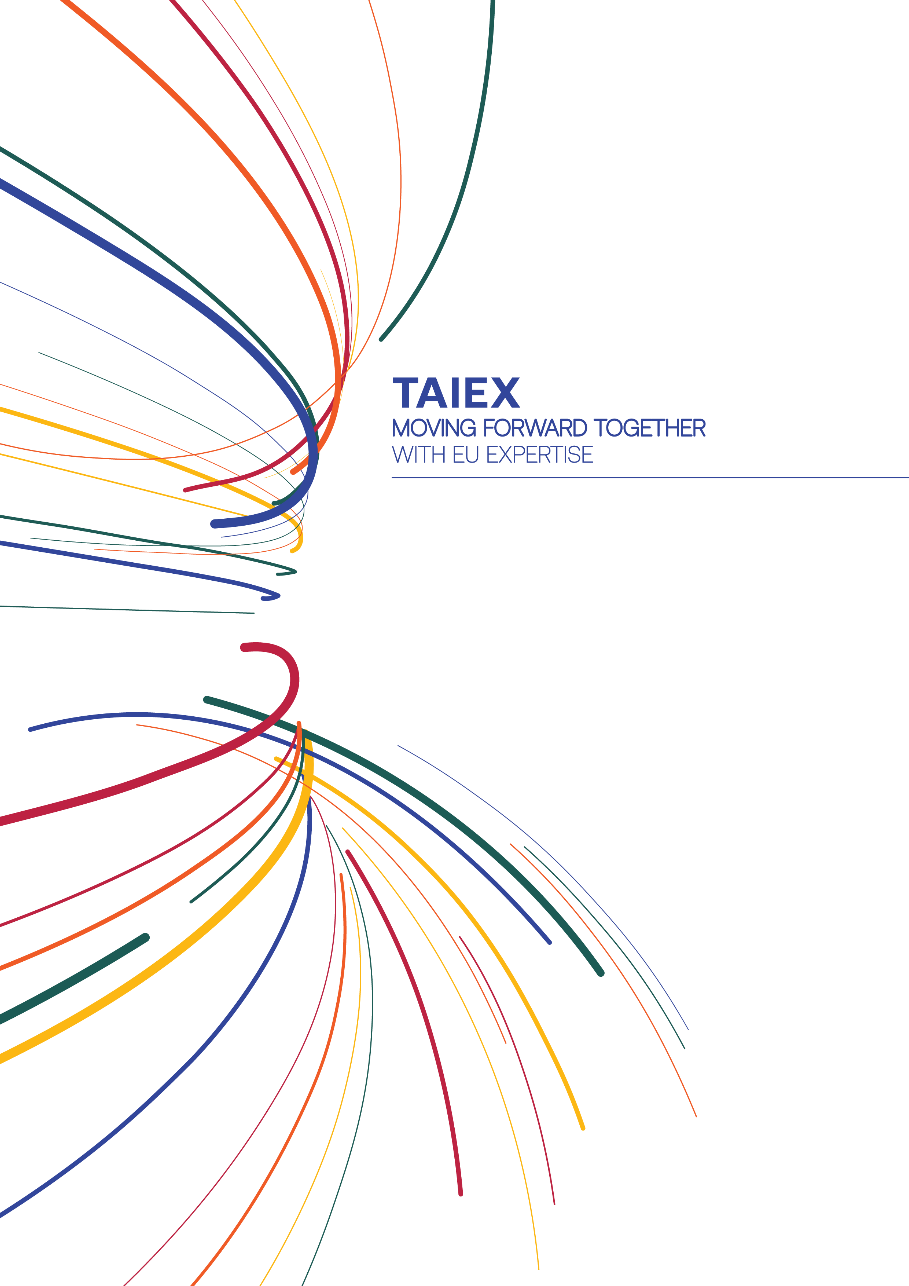

[near-taiex@ec.europa.eu](mailto:near-taiex@ec.europa.eu)

[ec.europa.eu/taiex](http://ec.europa.eu/taiex)

[@eu_near](https://twitter.com/eu_near) #EUTaiex





[facebook.com/EUNEAR](https://www.facebook.com/EUNEAR)